MASCHERPA Audric ROB 3 2022 / 2023

**POLY-SNAKE**

**Weekly report n°5 from 25/11/22 :**

Figure 5.1

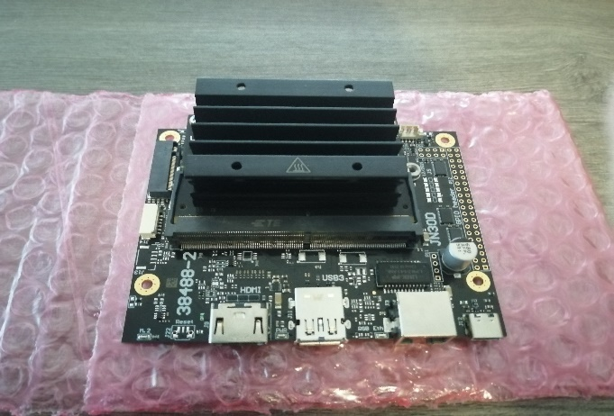

At the beginning of this session, I initialized the JN30D NVIDIA Jetson Nano card which is the control card that we will use me and my partner for our project in Figure 5.1. Thus, now that the control card has been initialized, we can use it later to operate the snake.

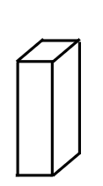Once this step is done, I continue modeling the head of the snake which will accommodate the control board. I also chose to change the position of the card in order to save as much space as possible and to have a head of similar size to the body.

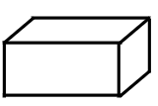

Figure 5.2

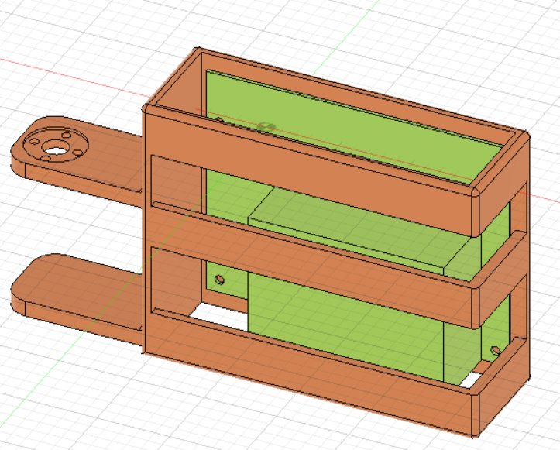Thus, I was able to model during the rest of the session the "skeleton" of the head of the snake which will come to receive the card, and which will be connected to the rest of the body in figure 5.2. We can see in green a modeling of the Jetson nano NIVIDA card and in orange the "skeleton" of the snake's head which has been modeled so as to be able to pick up the card, hold it in position using aim and nut and protect it from potential shock all without obstructing the different ports.

Particular attention has been paid to the thermal diffuser so that it does not melt the piece and does not overheat despite the absence of a fan. This also explains the presence of many holes around the card. It is also important to point out that the aesthetic aspect of the snake's head will be seen later so that I can concentrate for the moment on the practical and useful aspect.

Finally, I decided to model the head and the body of the snake on a single display in order to have an overview of the skeleton of the robot in Figure 5.3.

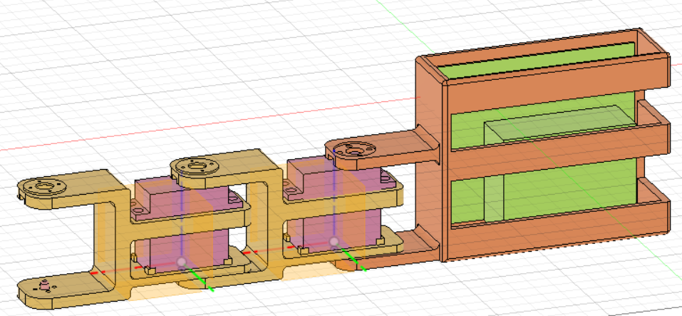

Figure 5.3

Once the movement program is finished, we can start the first tests on our project and model the tail that will accommodate the robot's power supply.